Case for Support
2017

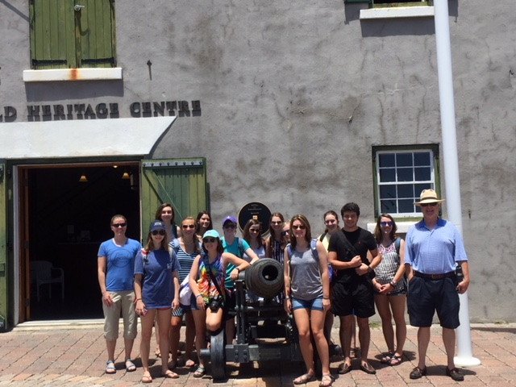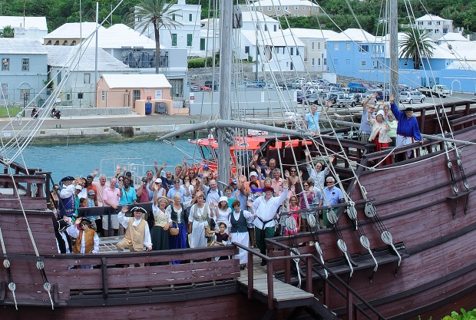

THIS IS OUR 20th ANNIVERSARY YEAR!

The St. George’s Foundation, registered charity #454, was established in 1997 as a result of a strategic planning and public consultation exercise, coordinated by the Corporation of St. George. The St. George’s Foundation was formed to work in partnership with the local community, Government and the Corporation of St. George to bring the unique history and heritage of the Town of St. George and its related fortifications to life for all, locals and visitors, to enjoy and appreciate.

The St. George’s Foundation and the Corporation of St. George worked closely together after 1997 and in 2000 the Historic Town of St. George and related fortifications received the distinguished designation of a UNESCO World Heritage Site having met the world standard (outstanding universal value) for such original historic sites.

OUR BELIEF

We believe that the secret to a successful heritage approach is collaboration; people working together. From collaboration comes empowerment, confidence and an integrated approach to the restoration, preservation and use of our historic assets and resources leading to economic opportunities, diversification, innovative products and community pride.

How do we do this?

World Heritage Centre:

- Home of the St. George’s Foundation
- Orientation and Educational Centre for the Town of St. George
- A state of the art introductory exhibit including a model of St. George’s in 1624.
- A 60-seat lecture hall with projected short videos on Bermuda’s history including our signature video “A Stroll through St. George’s ”
- Arranging local school visits, private groups and corporate tours of the town to begin at the World Heritage Centre where we are able to educate everyone on the early history of our Island and the Town of St George and why it is considered by UNESCO as being of “outstanding universal value”.
- A dynamic exhibit space, currently including paintings of historic significance, models to scale of our early ships and the well-attended Verpilleux Exhibit of massive oil paintings of Bermuda scenes from the 1940s

Deliverance:

- Continue enhancement and restoration of the life size replica of the Deliverance after she was badly damaged in a recent hurricane.
- The Deliverance dubbed “The Little Ship that Saved America” is an important icon for Bermuda and St. George built at Buildings Bay and outfitted right there at Ordnance Island in 1610. Continuous maintenance is essential and costly but worth every dollar.
- We are looking to include new exhibits in the Deliverance to add to our talking animatronic figure of William Strachey.
- Exploring partnerships with performance groups and event planners to put on presentations.

Partnerships (collaboration) with like-minded organizations for:

- Staging historical re-enactments like the St. George’s Gun Powder Plot.
- Producing historical documentaries like “Cedar, Sloops, and Slaves”, “Smiths Island Archaeology” and our “Maritime History”.
- Organizing and inviting overseas experts and historians to put on presentations such as “The Historic Atlantic Triangle” with Dr. William Kelso from Jamestown Virginia and Dr. Michael Jarvis on the Smiths Island dig.
- Putting on monthly film and lecture series in partnership with the Bermuda Tourism Authority and Community and Cultural Affairs
- Working with the Corporation of St George for the Roy Taylor Painting Exhibit (exquisite fish paintings from the 1950s) at the Town Hall.
- A founding partner of the Bermuda Heritage Partnership between the Bermuda National Trust, the African Diaspora Heritage Trail, the National Museum of Bermuda, and the St. Georges Foundation which promotes Bermuda’s culture and heritage abroad to customize tours for special interest groups, now known as Heritage Bermuda.

Please support us in these encouraging times and help us “Celebrate 20 Years of Bringing History to Life” within the UNESCO World Heritage Site to keep the passion and grow the momentum already underway. You can support us through attending our events, individual memberships and a donation general or specific.

Why It Matters
Economic and Community Development
With the announcement of an increased number of cruise ships sailing into the Town of St. George’s harbor, the rise in the number of ferries from Dockyard, the agreement for the Ordnance Island Marina to encourage Super Yacht Tourism, and the ground breaking for the development of the St. Regis Resort, these are all opportunities for our town to once again begin to thrive. We must take advantage of these exciting developments. The Town must develop hand in hand with these opportunities to ensure success for which we need your trust and support.

The new Cultural Tourism Manager, with the support of the Hub 1 Steering Committee, and the BTA, has taken on the role of the development and implementation of a three to five year cultural tourism plan for the Town of St. George and St. David’s. In addition to the BTA, the Hub 1 Steering Committee consists of The Corporation of St. George’s, The World Heritage Site Management Committee, East End Chamber of Commerce, Economic Development Company and Bermuda Land Development Company.

UNESCO World Heritage Site Status

With the granting of UNESCO World Heritage Status for the Town of St. George and its related fortifications comes the responsibility of protecting and preserving this historical site. We have an obligation to restore, maintain and preserve the unique history and heritage of Bermuda. The St. George’s Foundation is primarily responsible for the WORLD HERITAGE SITE MANAGEMENT COMMITTEE chaired by Dr. Charlotte Andrews who is eminently qualified for this responsibility. Participants in this committee are the St. George’s Foundation the Bermuda Tourism Authority, the Corporation of St George, The Parks Department, The Heritage Officer, the Planning Department, The Bermuda Economic Development Council, the Chamber of Commerce, Hub 1, St Peter’s Church, St. George’s Historical Society, Community and Cultural Affairs and Conservation Services. The role of this committee is to ensure compliance with the UNESCO requirements and all reporting, as well as ensuring that our historical assets are properly protected and restored.

Heritage: Education, Social and Community Development and Entertainment

The St. George’s Foundation, along with our donors, members, volunteers and other supporters, is striving to enhance and develop the heritage of St. George, the World Heritage Site, and St. David’s. Heritage is central to the sense of identity for the people and community of Bermuda.

We must improve the existing cultural and heritage attractions and keep them all open on a more consistent basis and offer additional interactive exhibits and events to attract more people to come and visit the Town of St. George. We intend to appeal to locals as well as visitors. Our history is socially important and provides context and the truth about our past which enables one to better understand the present and to have pride in our heritage. This in turn leads to a vibrant town with the full support and engagement of the local population.

Further, the close connection of Bermuda to the United States of America provides the relevance for our visitors, from the little ship that saved America in 1610, to the 1775 Gunpowder Plot, to the 1812 war, WW II with the US Base and our significant role during the Cold War.

Upcoming Projects

One of the projects listed below is “The Crossroads of the Atlantic” Exhibit based upon the chapters of the incredible book by Dr. Michael Jarvis (Associate Professor of History at Rochester University) entitled “In the Eye of All Trade – Bermuda, Bermudians, and the Maritime Atlantic World 1680 – 1783” (684 pages) packed with facts (until now unknown and unappreciated) based on his years of original research in the local Archives. This book has great educational value which when interpreted and presented in an efficient modern media format will contribute immeasurably and widely to the enrichment of our culture and the promotion of human understanding and fellowship. The media format means that the exhibit is flexible and transportable to schools and visitor venues and easily digested in substantially less time than it would take to read the book or chapter! One chapter “Cedar, Sloops and Slaves” has been completed in a 20-minute video and is currently showing at the World Heritage Centre. This video establishes the fact that the Africans and West Indians, notwithstanding slavery, contributed to Bermuda’s maritime success equally and powerfully. Our plan is to do three more at an estimated cost of $80,000 ($20,000 for each chapter and $20,000 for outfitting and equipment).

Reverend Pinkney: “We [Blacks] have a deep appreciation of history – We haven’t always had a deep appreciation of each other’s history”. This “Crossroads” video brings the two histories together and is about Bermudians.

Whilst we encourage and prefer unrestricted donations to retain flexibility, if you would prefer to direct your investment towards a specific project or exhibit, please see the list below. A brief description is provided, but a full overview of each item can be forwarded upon your request. The amount listed is the total cost of the project/exhibit.

Any donation for a specific project/exhibit will include a portion applied to administration which will be necessarily directly involved and responsible for carrying out the project.

Proposed Projects and Opportunities
- The celebration and recognition with Jamestown, Virginia and Bermuda in 2019 and 2020 respectively. The 400th anniversary of the founding of our respective General Assemblies, and the seeds for our systems of democracy and representative government today. Cost to be determined
- The possible electronic interactive exhibit of St. George in 3D over the centuries and the use of holograms and 4D exhibits are expensive, but it is where museums/exhibits are going.
- The reenactment of the Gunpowder Plot at Tobacco Bay for August 2018 $10,000
- World Heritage Centre general restoration to include pest control tenting;
wall leak repairs; blinds, shutters & doors repair & paint;
prepare, seal and paint interior & exterior $ 85,000
- Continued “Deliverance” replica restoration & new exhibits on board $ 25,000
- Historical Property/Artillery Upgrades $25,000
Includes restoration of canons on display at various fortifications
- Community/Education Events & re-enactments
to include WHC Lecture and Film Series $12,000
- World Heritage Centre Exhibits
- The Crossroads of the Atlantic Exhibit, (see above discussion)
Continued adaptation of the book “In the Eye of all Trade”
into 3 more informative videos $80,000
- Rolfe, Pocahontas and Tobacco Exhibit with Jamestown VA $ 15,000
- Pilot Gig Rowing & Sailing History Exhibit $ 15,000
Includes the “Jemmy” Darrell exhibit
- Early Settlement History Exhibit $ 8,000
Includes curation of the Grimes paintings and model ship displays

Proposed Additional Fund Raising Projects:
- Anniversary Raffle - 1,000 tickets at $50 per ticket for a donated
Travel Voucher worth $10,000 $40,000
20th Anniversary Gala Event on 12th May 2018 $80,000

If you wish to consider sponsoring any one of these projects/exhibits, our team would be pleased to present a more detailed plan.

We can supply a copy of our most recent Audited Financial Statements upon request.

We are a Registered Charity #454 in full compliance.

We attach our membership application form and our instructions for a donation for your use and guidance.

All detail is featured on our web site, www.sgf.bm

Please contact our General Manager, Peter Frith at manager@sgf.bm or 297 8043 should you wish to sit down with some of our Board of Trustees for further one on one discussions.

And THANK YOU

